How to Update Your Personal Information (online)
Log-in to your account at www.yourbenefitaccount.net/pensioninc/ or www.pensioninc.net

From the Dashboard Summary > Select Settings Gear Icon in Top Right Corner

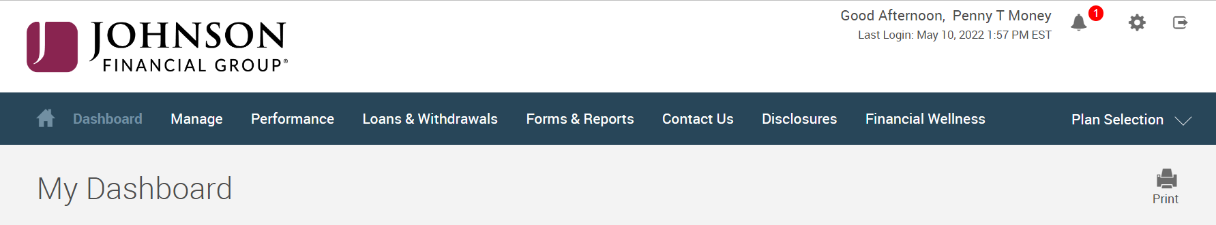

From Drop Down Menu > Select Personal Info
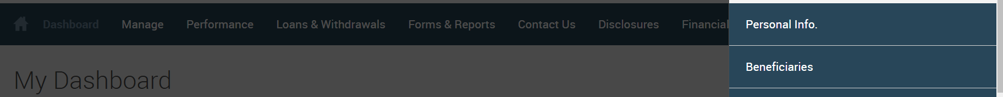

Edit Personal Information > Click Each Arrow to Verify/Update Demographic Information > Click Submit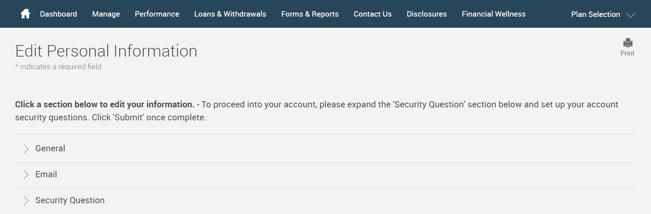

You will receive a GREEN Confirmation Code
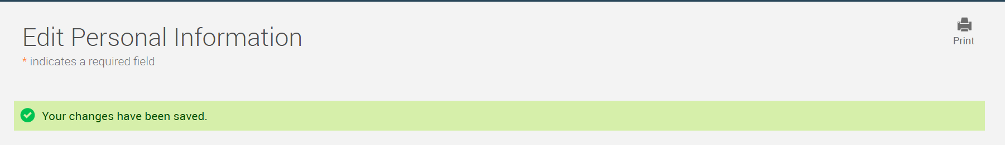

All changes require an overnight cycle to appear online and will be processed as soon as administratively feasible in accordance with your plan provisions.
Read Summary Plan Description (located in Forms) for more information

Please contact the Participant Support Center at 1.920.432.7020 or 1.877.865.7899 with any questions

